


DOCUMENT STORAGE & ARCHIVAL BOXES

Organize. Protect. Retrieve.

Professional Corrugated Storage Solutions by ESTI Packaging
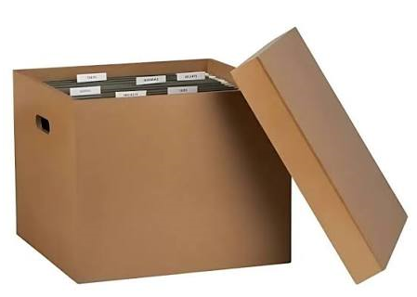
ESTI Packaging manufactures custom-designed corrugated document storage and archival boxes for the safe, organized and long-term storage of files, records, documents and valuable paper collections.
Designed for offices, corporates, institutions, warehouses, archives and record-management facilities, our storage boxes combine strength, functionality and easy handling with fully customizable dimensions and printing.
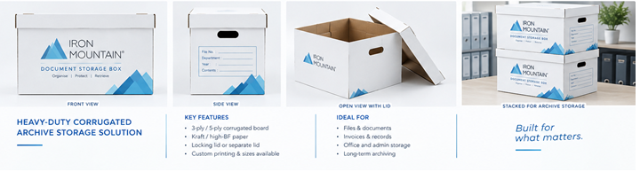

DOCUMENT STORAGE CORRUGATED BOXES
Keep your records organized, protected and easy to access.
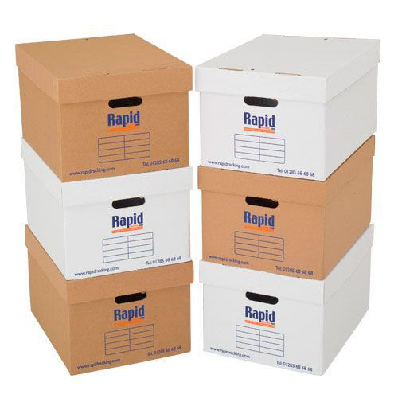
Our corrugated document storage boxes are designed for storing:
- Office files and documents
- Invoices and financial records
- Legal and statutory records
- Personnel files
- Project documentation
- Books, brochures and magazines
- Historical records and paper collections

Key Features
Strong & Stackable
Manufactured using 3-ply or 5-ply corrugated board for reliable stacking and storage performance.
Locking Lid / Hinged Lid
Choose from locking-tab designs, hinged lids or separate lids according to your application.
Easy Identification
dedicated label areas can include File No., Department, Year, Contents and other identification fields.
Easy Handling
integrated hand-holes make boxes easier to lift, carry and retrieve from shelves.
Custom printing
1–2 colour printing or customized graphics for identification, branding and document classification.
Moisture-Resistant Options
Special board and coating options are available for environments where additional moisture resistance is required.
Partitions & Dividers
Optional internal partitions help organize multiple files and prevent movement during storage.

HEAVY-DUTY RECORD STORAGE BOXES
For warehouses, archives and high-density record storage, ESTI Packaging offers 5-Ply BC / EB flute heavy-duty corrugated boxes designed for higher stacking strength and demanding storage conditions.
Our engineering team can optimize the board grade, flute combination, dimensions and box construction according to the required load, stacking height and storage duration.

TYPICAL DOCUMENT STORAGE BOX
400 × 300 × 250 mm
A commonly used format for A4 files and office records. Dimensions can be customized according to file thickness, document quantity and storage system.

Customization Available
- Length × Width × Height
- Board strength
- 3-ply / 5-ply construction
- Flute profile
- Lid construction
- Locking mechanism
- Hand-hole design
- Internal dividers
- Printing
- Label area
- Surface treatment
- Moisture-resistant construction

ARCHIVAL STORAGE BOXES

Protect Important Records for the Long Term
For documents and collections requiring additional protection, ESTI Packaging can develop archival-style storage boxes using carefully selected paper and board specifications.
These solutions are suitable for:
- Historical documents
- Photographs
- Manuscripts
- Maps and drawings
- Books and publications
- Artwork and prints
- Textile documentation
- Institutional records
- Museum and library collections
Where archival specifications are required, paper chemistry and material specifications can be selected according to the intended preservation requirement.

DROP-FRONT ARCHIVAL BOXES

Easy Access. Better Organization.
Drop-front boxes are designed for collections that need to be stored securely while remaining easy to access.
The drop-front construction allows documents, photographs, artwork, prints, brochures, newspapers and other flat materials to be removed without unnecessarily disturbing the rest of the collection.
The box can be engineered with a hinged front panel, removable lid and reinforced construction according to the required application.

DOCUMENT FILE BOXES - RECORD STORAGE BOXES.

Store More. Organize Better.
ESTI Packaging's record storage boxes are designed for organizations that need to store large volumes of documents efficiently and securely.
Suitable for:
Corporate Records | Financial Records | Legal Documents | HR Files | Medical Records | Project Files | Government Records | Warehouse Archives
Boxes can be supplied with custom dimensions, identification printing, indexing areas and internal dividers to suit your record-management system.

Designed Around Your Filing System
Our document boxes can be configured for vertical or horizontal storage of A4, Letter, Legal and other file formats.
A one-piece hinged lid or separate-lid construction provides convenient access while protecting documents from dust, handling and storage damage.
Optional file dividers and spacers can be incorporated to keep files upright and properly organized, even when the box is not completely full.

WHY ESTI PACKAGING?

Packaging Experts. Strength Engineered. Protection Delivered.
At ESTI Packaging, we don't simply manufacture a box. We develop the right packaging structure for the application.
Our team can assist with:
- Box design and structural development
- Board and flute selection
- Strength optimization
- Custom dimensions
- Printing and identification
- Prototype development
- Heavy-duty packaging solutions
- Bulk production

One Box. One System. Better Records.
From everyday office files to heavy-duty warehouse archives, ESTI Packaging provides customized corrugated storage solutions designed around your requirements.
Need a custom document storage box?
Share your box dimensions, file size, quantity and application with us. Our team will recommend the appropriate construction and board specification.

